**JOB RECRUITMENT & HIRING MANAGEMENT SYSTEM**

**NAME: KOLLI JAGAN MOHAN RAO**

**Phase 9: Reporting, Dashboards & Security Review**

**Objective**: To create analytical tools for business users to visualize key metrics and to perform a thorough review of the application's security model to ensure data is properly protected.

**Reporting**:

**Implementation**:

* 1. A new **Report** was created using the **"Jobs with Applications and Candidates"** custom report type, which provides access to all necessary fields.
  2. The report data was **grouped by** the **Application.Status** field.
  3. Key columns such as Application Number, Candidate: Name, and Job: Name were added for detailed analysis.
  4. A **Funnel Chart** 🔻 was added to the report to visually represent the number of applications in each stage, from "New" to "Hired."

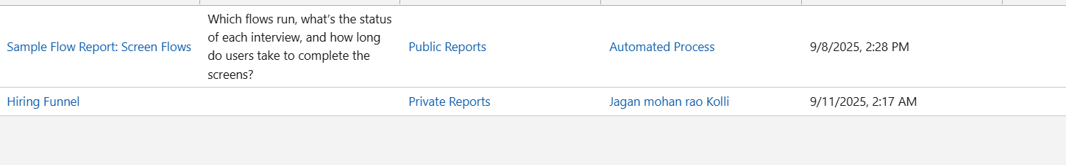

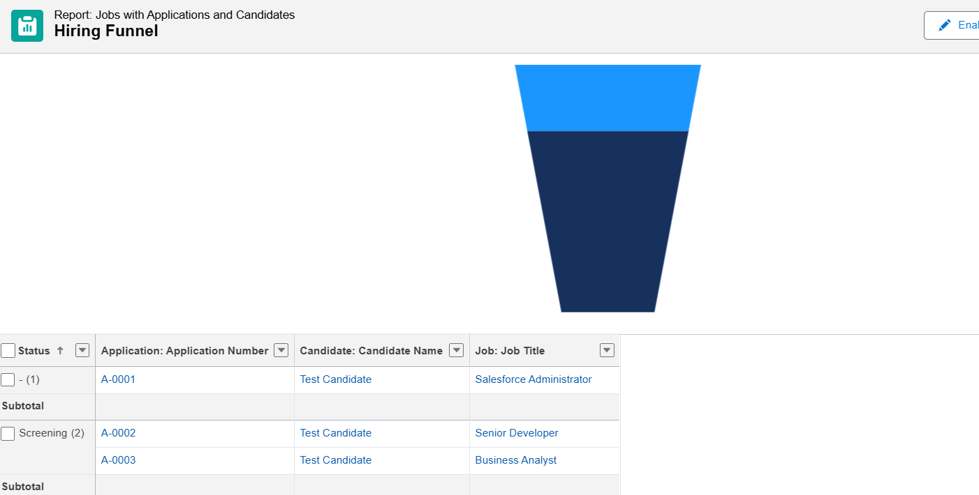

**Dashboards**:

* **Implementation**:
  1. A new **Dashboard** named "Hiring Dashboard" was created.
  2. The **"Hiring Funnel" report** was added as two separate components to showcase different visualizations from the same data source:
     + A **Funnel Chart** component to display the hiring pipeline visually.
     + A **Gauge** component to display the total number of applications (Record Count), providing a clear metric of the overall workload.

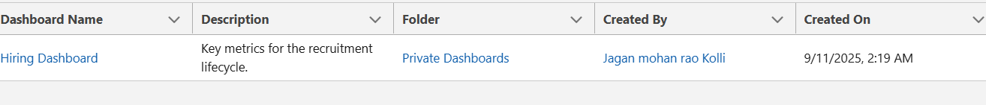

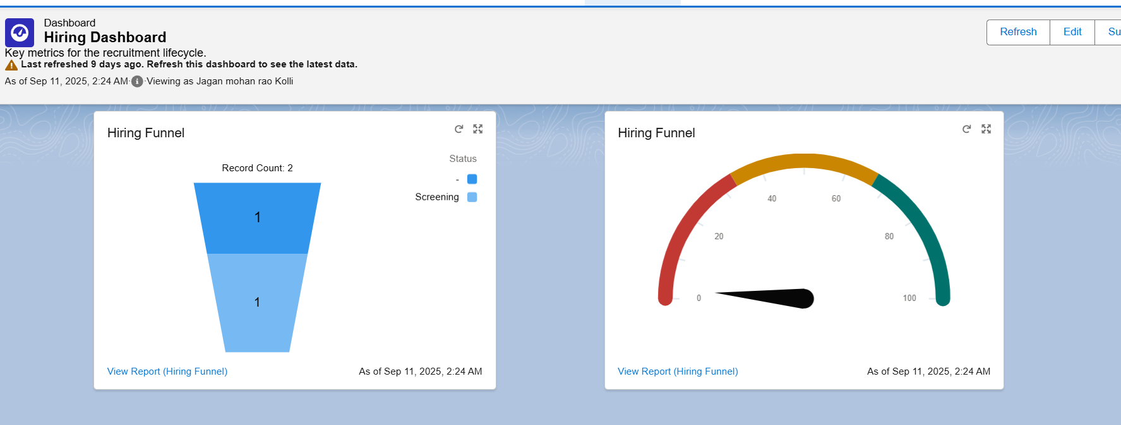

**Security Review**:

**Implementation**:

* 1. **Organization-Wide Defaults (OWD)**: The OWD for the Job__c and Candidate__c objects was verified and set to **Private**. This established the foundational rule that no user can see a record they don't own by default.
  2. **Record Ownership**: A test case was performed where a Hiring Manager user ("Priya Sharma") was made the **owner** of a specific Job__c record and its related parent Candidate__c record.
  3. **Login As & Verification**: The **Login As** feature was used to sign in as the "Priya Sharma" test user. It was confirmed that she could **only see the specific Application__c record** for which she owned both parent records. All other applications were hidden, proving the "Controlled by Parent" sharing and private OWD model were working perfectly.

